**Name: Aqsa Khurram**

**SAP ID: 50086**

**Subject: Web Programming**

**Assignment-02**

**Question-01**

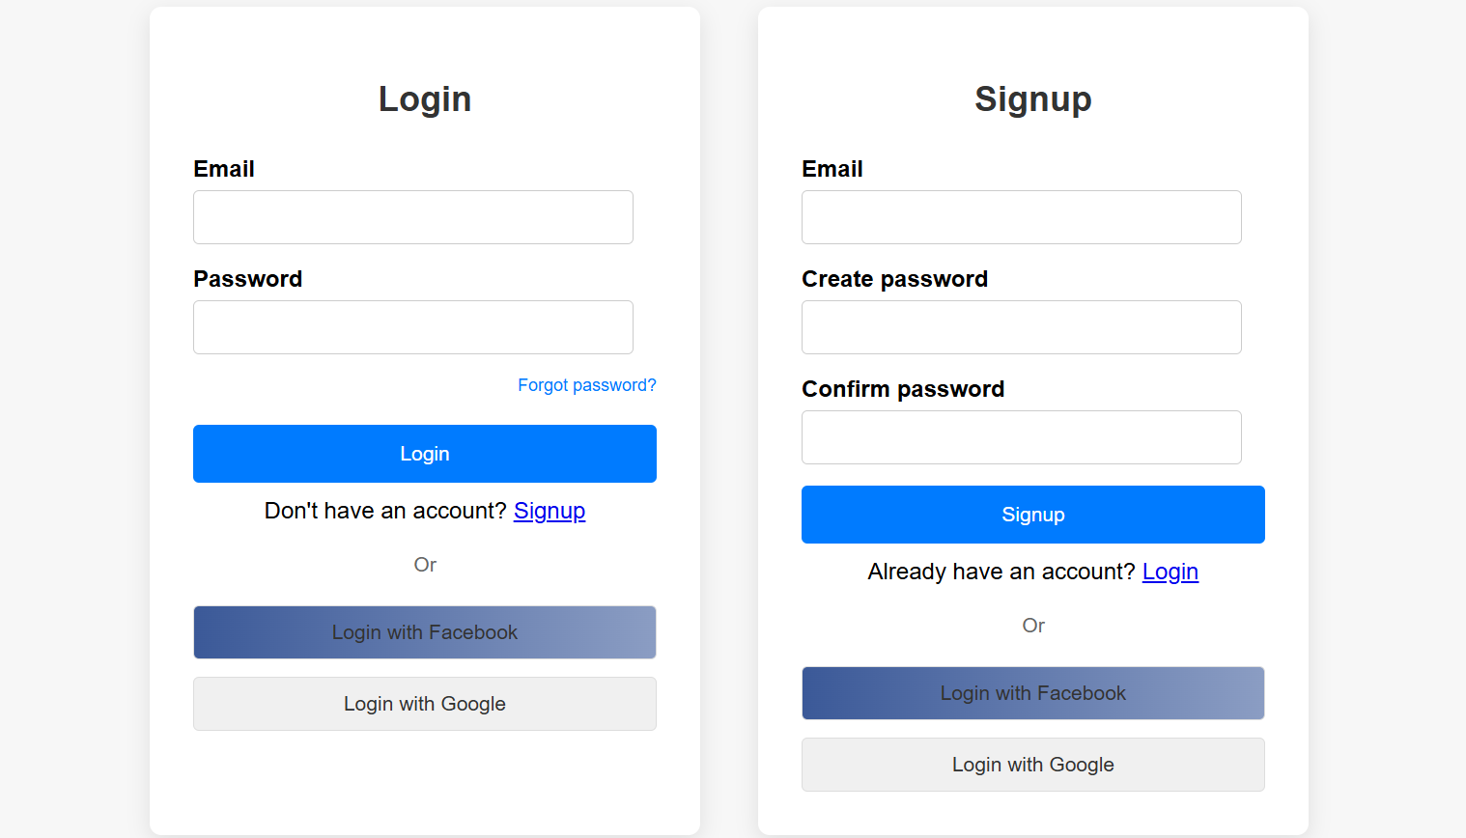

**Question-02**

